Finals Task 2.
Working and Navigating through Power BI
Instruction: This task will allow you to navigate and put together the Power Bi workflow form Data Preparation, Modeling, Analysis and Visualization.
Part 1. Data Acquisition. Download the flights_data.csv and airports.csv for the dataset that you need to work on, your task is to clean and prepare the data ready for modeling. The dataset is currently in a form of flat csv file; you are to check and correct necessary data cleaning task.
- Make sure all columns are properly labeled
- You may replace all blank values under cancellation reason to “Security”
- Remove unnecessary columns specially those that contains blank entries
- Split necessary dim tables for the airline, cancellation_reason, airports
- Add from the data source the airports.csv file
Double check the columns in your tables (You should have 1 fact table and 3 dim tables)
Part 2. Data Model – Design the data model – using Star Schema
Part 3. Do the necessary Measures and Calculated Columns use DAX and organized your measures into folders (by going to the Model view-Click Data) then under properties – add a folder named measures and put all measures in the folder
Here are the measures:
Calculated Columns: (Add Column from the Data view)
STATUS = IF(flights[CANCELLED]=1,"Canceled", IF(flights[DEPARTURE_DELAY]>0,"Delayed", "On-Time"))

- Total Flights = COUNTROWS(flights)
- % Canceled = DIVIDE([Canceled Flights],[Total Flights],"-")
- % Delayed = DIVIDE([Delayed Flights],[Total Flights],"-")
- % On-Time = DIVIDE([On-Time Flights],[Total Flights],"-")
- Canceled Flights = CALCULATE([Total Flights],flights[CANCELLED]=1)
- Delayed Flights = CALCULATE([Total Flights],flights[DELAYED]=1)
- On-Time Flights = CALCULATE([Total Flights],flights[STATUS]="On-Time")

Include the ff: measures as well and construct the appropriate formula
- Total Diverted Flights
- Totals of On-Time Flights
- Totals of Cancelled Flights
Part 4. Do the necessary visuals for all the measures computed
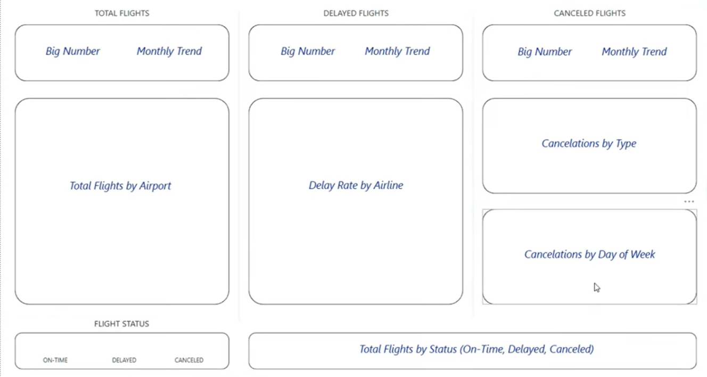

Final Design – Explore the formatting tool of Power Bi visuals
